**DICTIONARY USING LINKED HASH**

**LOW LEVEL DESIGN**

**Overview of DICTIONARY:**

The main objective of this project is to load words from file to main memory (linked hash) and provide features where user gives the word and returns its meaning of the word.

**Procedure Flow:**

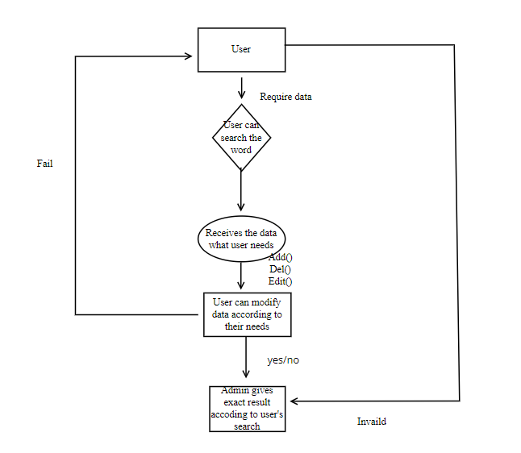

**USER:**

User searches the word from dictionary on which he wants to perform his desired task.

**RETRIEVES THE DATA:**

User receives the data that he has searched from the admin .

**MODIFICATION:**

User has access to data and can modify the data like adding, deleting, and editing of data.

**RESULT:**

The admin will give the exact result for what the user desired.